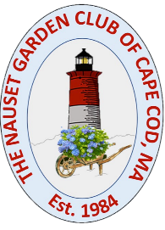
NAUSET GARDEN CLUB
GO GREEN AND PROTECT OUR POLLINATORS
2021 MINI-GRANT APPLICATION

Please fill out this simple application for our Mini Grants of up to $500 or up to $1,000.
Please submit this form, by November 1, 2021, to Melissa Brown at missiebrown121@gmail.com

Teacher Information
Name______________________________ School_______________________________

Subject Area________________________

Applicant’s Email Address _______________Applicant’s Phone # ___________________
For Award Check please specify
“Pay to the order of” _______________________________
Check mailing address ________________________________________________________________________

Student Information: specify student participants in your “Go Green and Protect our Pollinators” Project

Grade(s):

Subject

Project Title and Vision

Project Activities

Amount Needed

